BILLING REPORT
Introduction
This project aims to understand what has happened from January to march based on client calls revenue and carrier cost. The Total billing per client, Gross Margins % by Client, Country, by Carrier, by number, total cost of vendor has been reviewed and recommendations have been made
Based on the data given and your problem statement. Here are the outcomes from my analysis.

Data Transformation
I had to combine all the individual sheets as a new table(sheet) to have a better understanding of billing information from January to March which also simplified the creation of an interactive dashboard.
The data consisted initially of 5 worksheets – Jan, Feb, March, Rates- Clients. Rates – Carrier. Which were merged to create the Working data Worksheet.

Insights From Exploratory Data Analysis (EDA)
Key Performance Indicators
- Total Clients
The company had 53 clients through January to March
- Revenue From Client Calls (Total Client Bill)
The total revenue from January to March was $84,540.40. This is based on the vendor used per call for clients from both landline and mobile phones and that Clients are billed per minute.
- Total Cost from Carrier Vendors
The total cost spent on calls from January to March was $655,159.156. This again is based on the vendor used per call for clients from both landline and mobile phones. The cost is so high because vendors bill the company at different rates.
- Net Profit
Due to the high cost spent on carrier vendors cause of differing rates, the net profit is -$570,618.753. So the company had a significant loss due to paying for client calls, but receiving little in client bills due to differing rates.
- Gross Margin
With a loss the company has a -675% gross margin from January to March

Total billing per client (Top 10)
Based on the data the top 3 clients which brought in significant revenue to the company due to the duration of their calls where Clients, 4, 37 and 8 with revenues greater than $15,000.
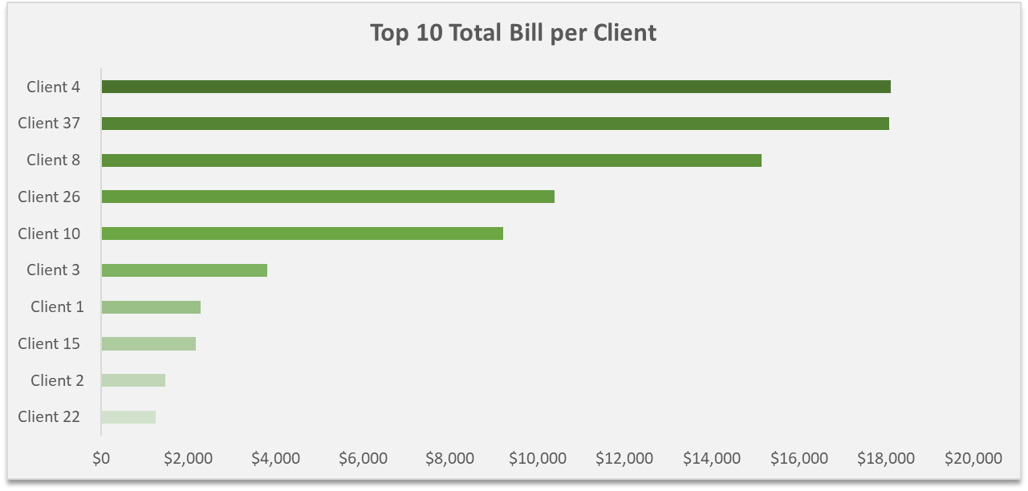

Gross Margins % by Client
Due to the company spending more on footing the client calls than making money from those calls, majority of the calls brought in losses to the company. So therefore the gross margin % are mostly in losses too, with just a few clients given the company little profits and gross margins.
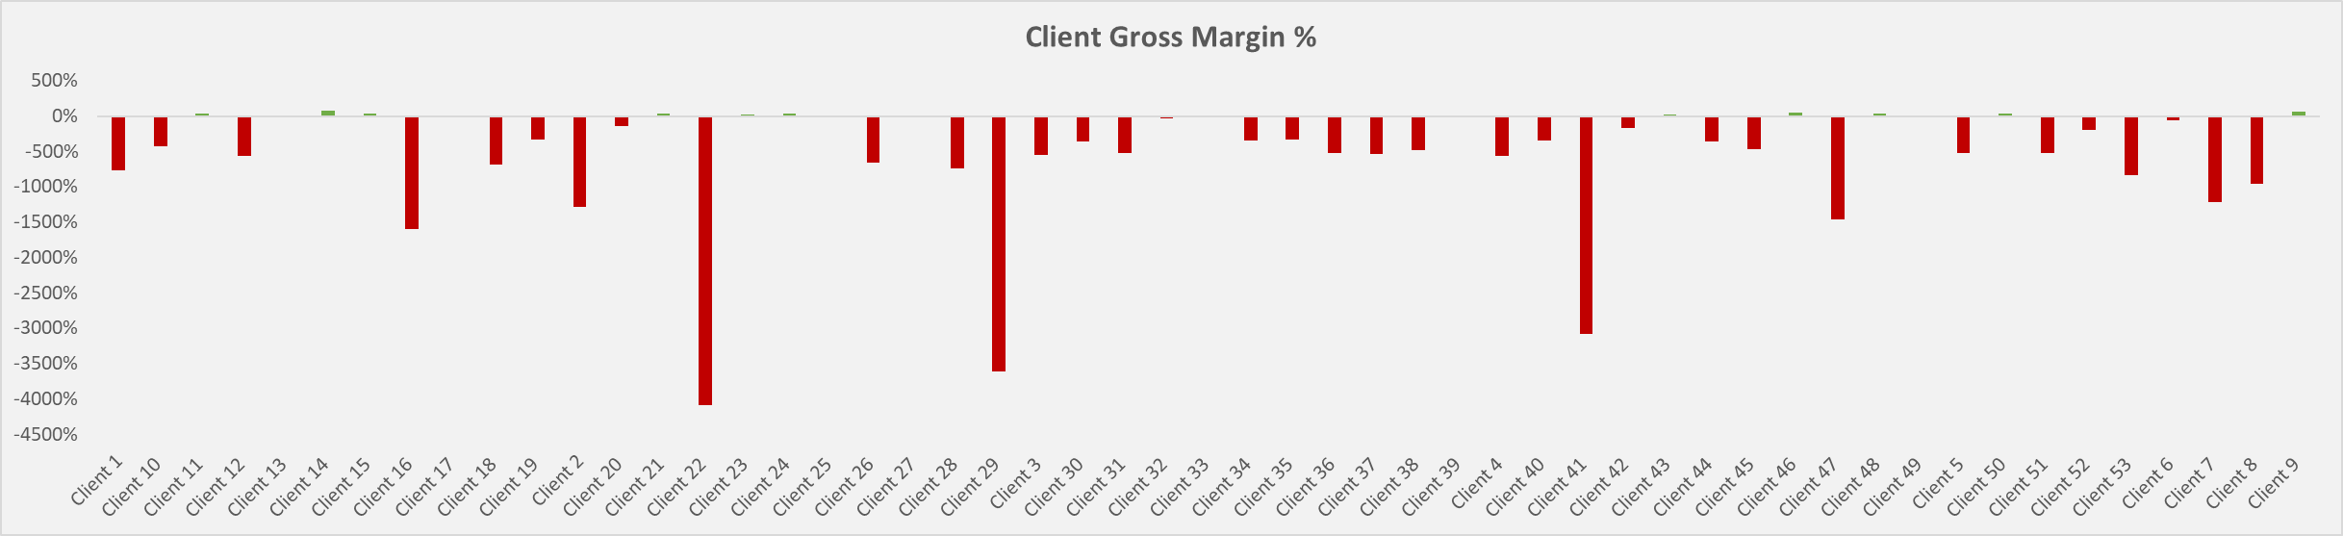

Gross Margins % by Country
Gross margin per country for the countries in the data were all negative, with Chile bringing in very significant losses.
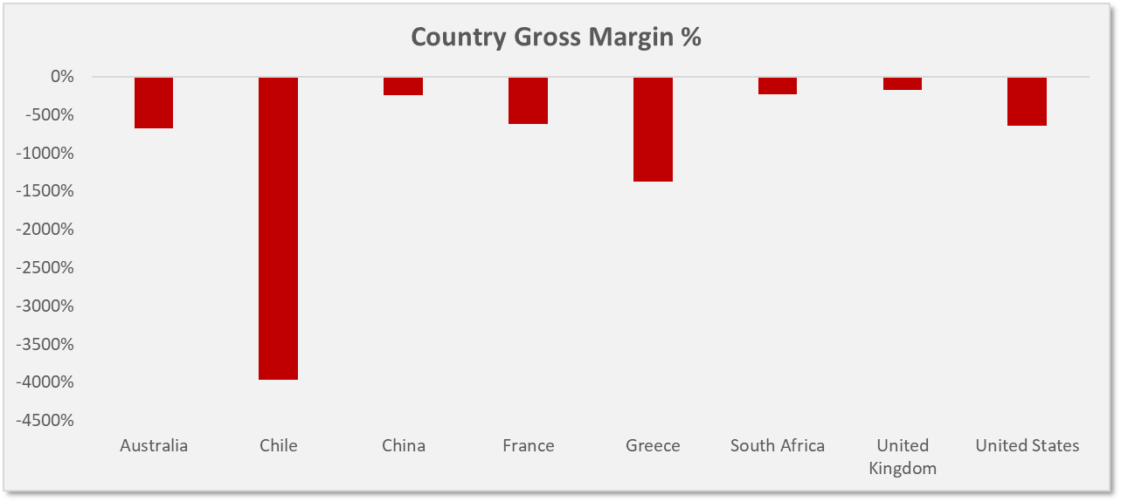

Gross Margins % by Carrier Vendor
Carrier vendors that the company has profit in are Vendor 3 and 5. This is due to them charging per minute and per 30 seconds respectively and the company also charging per minute for each call, hence the little total gross margin % for those vendors.
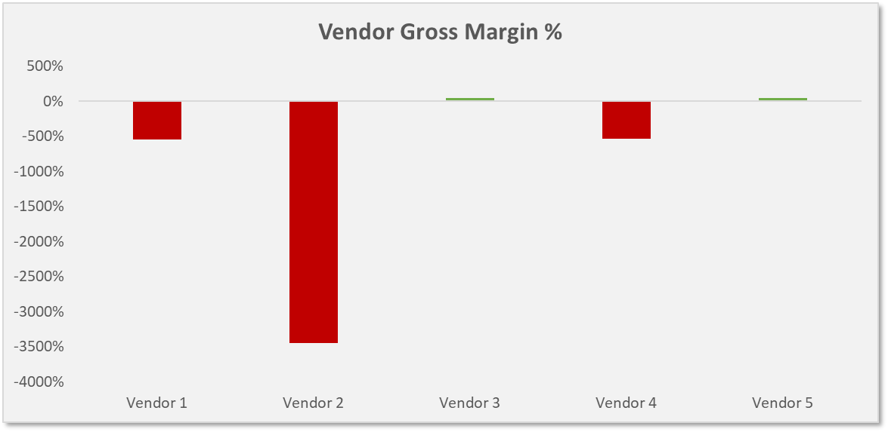
Gross Margins % by Number
They are 375 unique phone numbers that made calls within these 3 months so due to the large quantity of phone numbers. The top 20 and bottom 20 numbers and their gross margin %. This is not taking in to account or checking the vendor that was used for these calls.
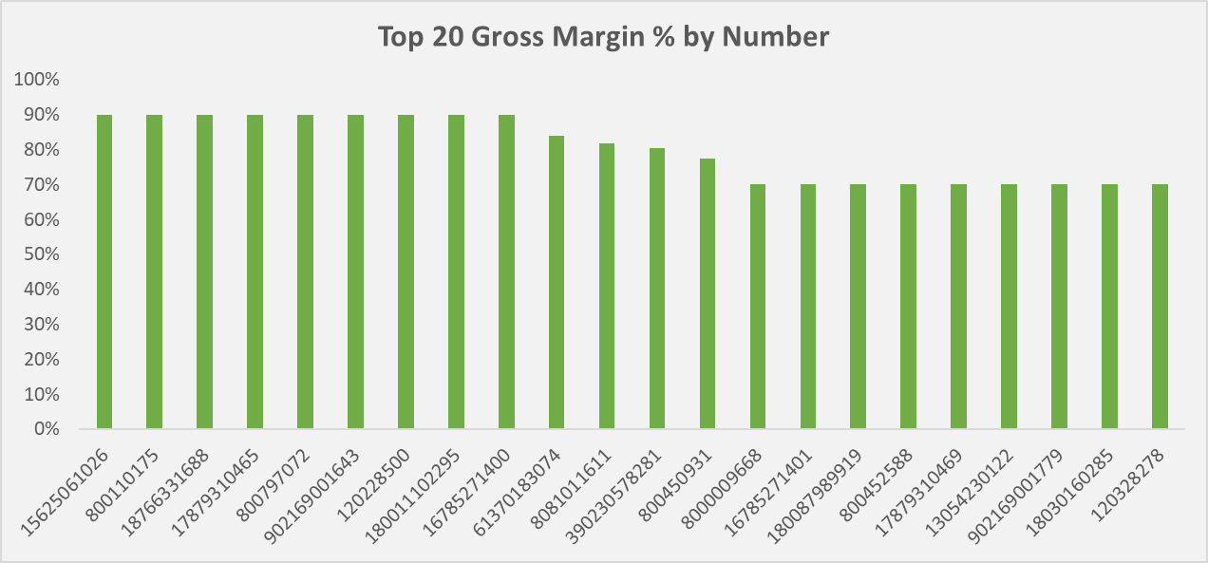
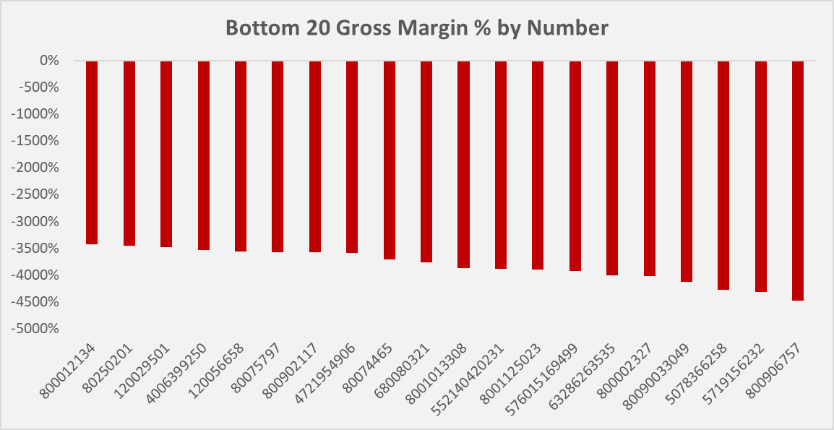

Total Cost per Vendor
As seen above the vendor with the highest cost paid by the company is vendor 2 which is also the vendor with the lowest gross margin, followed by vendor 4 and 1.
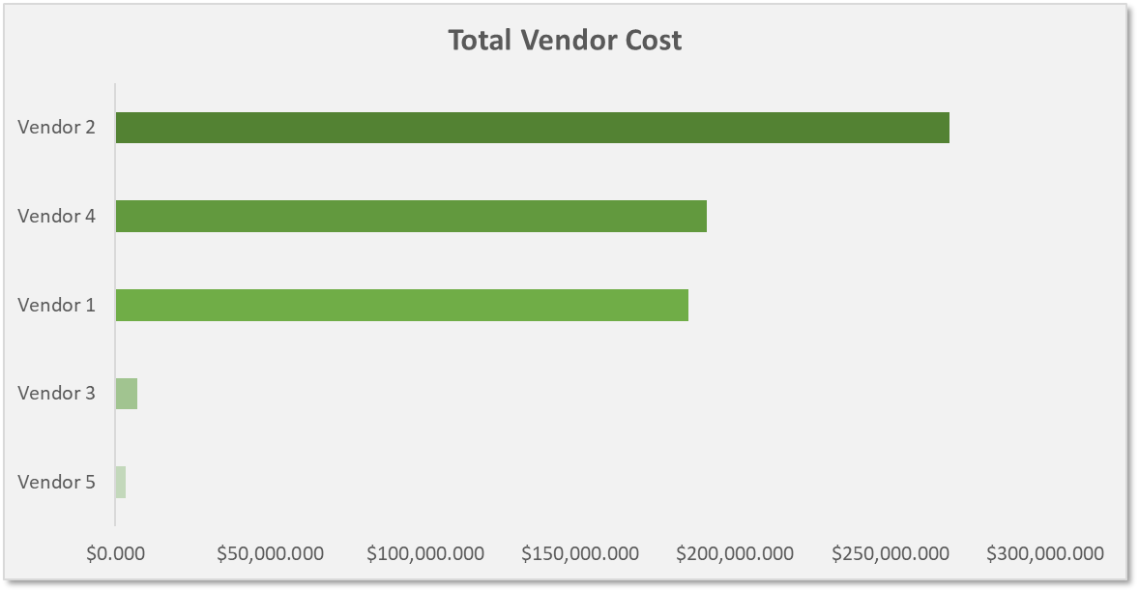
Gross Margin % by Country and Vendor
Although overall the gross margin per country is negative. When looked at per vendor, the gross margin for certain vendors (3 and 5) are positive.
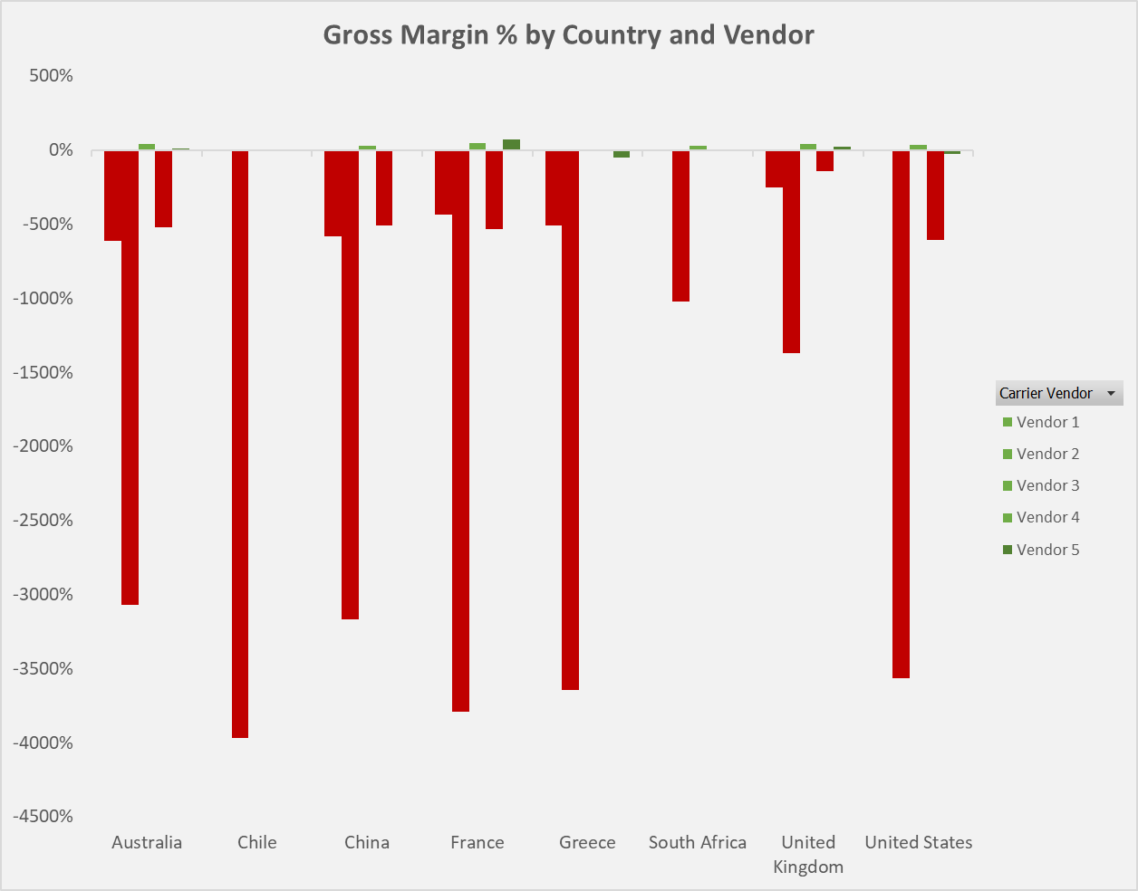
How would the above outcomes change if the mobile rate and landline rate increased by 7% and 20% respectively
After increasing the rates the company charges for client calls, it was observed that the Total Client bill increased by 13% (from $84,540.4 to $95,236.8) and the Gross margin also increased by 13% (from -675% to -588%). The total bill per client, gross margin % per country, per client, per vendor, per number also increases too
Since the increase is in client rates the total vendor cost remains the same.
Gross Margin of 45%
There are different ways in which things can be altered in order to get a gross margin of 45%, considering that it all starts from the vendors that bill the company, although the rates of different vendors may be cheap when compared, the fact that the vendors charge based on different increments like 1 second, 6 seconds etc while the company charges per minute will lead to losses and we saw this in vendor 2 mostly which charges per second. Vendor 1 and 4 were also led to the company having losses because they bill per second. However for vendor 3 and 5 which charge per minute and per 30 secs respectively are observed to have brought profits to the company.
So what I would suggest is to have a change of vendors for client calls. The company bills per minute, so the company should also use a vendor that bills per minute in this case “Vendor 3”. So as to mitigate these losses. By doing this the total carrier cost decreases drastically to a $55,032.52 from $655,159.15 (a 92% decrease). With this change, net profit also increases by 105% (to $29,507.88), which in turn turns the Gross margin to 35%.
A mobile rate increase and landline rate increase of 7 and 20 % respectively will only take the gross margin to 42%. So, to increase the gross margin to 45%, the mobile rate will have to increase by 12% and landline rate by 25%. I chose these values so as not to charge the clients too much while still making profit.
All these changes can be done and played around with in the dashboard in the excel file
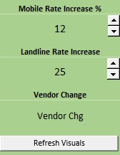
- Mobile rate and Landline rate increase buttons can be used to check how increase in mobile rate will affect the KPIs (Total client bill, Net profit, Gross Margin %).

- Vendor Change is a drop down that helps you see the original vendors (Carrier Vendor) used per call and the change to vendor 3 (Vendor Chg) per call which will affect the Total carrier bill, Net profit and the Gross margin %.

- To show the updated change on the dashboard charts, click on the refresh visuals button to refresh and show the change on those charts.

Observations and Recommendations
- They are 53 clients in total and 375 phone numbers, meaning some clients have multiple phone numbers. These numbers are connected to different vendors who bill on different increments. I would suggest to change the bill increment, the company may try billing the clients exactly the way the vendors bill them (if vendor 1 bills per 6 seconds, the company also bills the clients per 6 seconds), considering the carrier cost is lower and the client bill is higher.
By doing this the company will still have a total carrier cost of $655,159.15, but the total client bill will increase significantly to $975,720.31, with a Gross margin of 33%. If 45% gross margin is still needed then, the mobile rate and landline rate can be increased by 17 and 26% respectively.

- Vendor 1 and 2 are both costly to finance due to their bill increment and this can lead to significant losses as time goes on. So switching out these vendors for others with better increments which won’t be high to finance will be a better option. For example switching to vendor 3 or 5.

- Taking that into consideration that Vendor 2 is the only vendor being used in Chile, the company may decide to bill client the same way vendor 2 bills them or by incrementing by a second to bill clients. This can help the company still have business in Chile and also increase revenue and gross margins.

Dashboards
